

Participant Notebook:  
Learning a language from Videos

Spring 2025

This notebook belongs to: participant 2

Link to Zeeguu: [zeeguu.org](http://zeeguu.org)

**Introduction 3**

Date 3

Goal 3

Your Notes 3

**Session 1 - Article 5**

Date 5

Goal 5

Your Notes 5

**Session 2 - Article + Exercise 6**

Date 6

Goal 6

Your Notes 6

**Session 3 - Video 7**

Date 7

Goal 7

Your Notes 7

**Session 4 - Video + Exercise 8**

Date 8

Goal 8

Your Notes 8

# 

# Introduction

We have developed this notebook to guide your note-taking during the study. The insights we uncover in this study heavily rely on extracting your experience from each session, so feel free to go crazy on the notes!

In the below, we explain each section of the session notes.

## Date

* This should be the date that you complete the session.

## Goal

* This part will instruct you on what your goal is with the session.

## Your Notes

* This is where you put in your notes about the session.
* Aim for at least 3 bullet points for each session.
* We keep an eye on this notebook in case you get stuck. In which case we will reach out to you and help solve any issues you may have.
* At the end of the study we will use your notes to have a discussion about learning languages via videos.
* So what should your notes be about?
  + Something that was frustrating
  + Something that is missing
  + Something you liked
  + Something that surprised you
  + etc.
* Examples
  + *“I really liked that I could translate words while watching the video”*
  + *“Bad: finding a video I liked was too hard”*
  + *“I’m not sure if I completed the goal of this session, but what I actually did was…”*
  + *“Where is the save video button??”*
  + *“Watching the video takes too long because…”*
  + *“I was surprised to find out that…”*
  + *“I didn’t know that I could watch the video in fullscreen.*
  + *“This session was a bit difficult because…”*
  + *“Good: Rewatching the video a few times works a lot better for me*

# Session 1 - Article

## Date

* 22/04/2025

## Goal

* ~~1. Read an article on Zeeguu that you find interesting and challenging~~
* ~~2. Translate the words in the article that you don’t understand or find difficult. If you don’t need to translate any words, the article is not challenging enough.~~

## Your Notes

* After watching the introduction video, I founded the platform easy to use
* I like hearing the pronunciation as well as seeing the translation of the unknown words
* At the same time, I like having the option to deactivate the sound if wanted
* There was a small delay between clicking and getting the translation
* Could be nice to have a “reading out loud” option to hear the whole article (like DR has)

# Session 2 - Article + Exercise

## Date

* 25/04/2025

## Goal

* ~~1. Read an article on Zeeguu that you find interesting and challenging~~
* ~~2. Translate the words in the article that you don’t understand or find difficult. If you don’t need to translate any words, the article is not challenging enough.~~
* ~~3. Spend 5 minutes trying out the exercises~~

## Your Notes

* It took me a few minutes to find an article that I found interesting this time
* Translation for one word didn't feel right, and then I found out that I can see different options/sources for translation, and then choose the right one. That is a positive feature
* Exercises were good to absorb the meaning of the words, but I was lacking some grammar input: is this a verb, an adverb, a noun? If it’s a verb, what is the infinitive form? Etc. Dictionary definitions can help as well, not just direct translation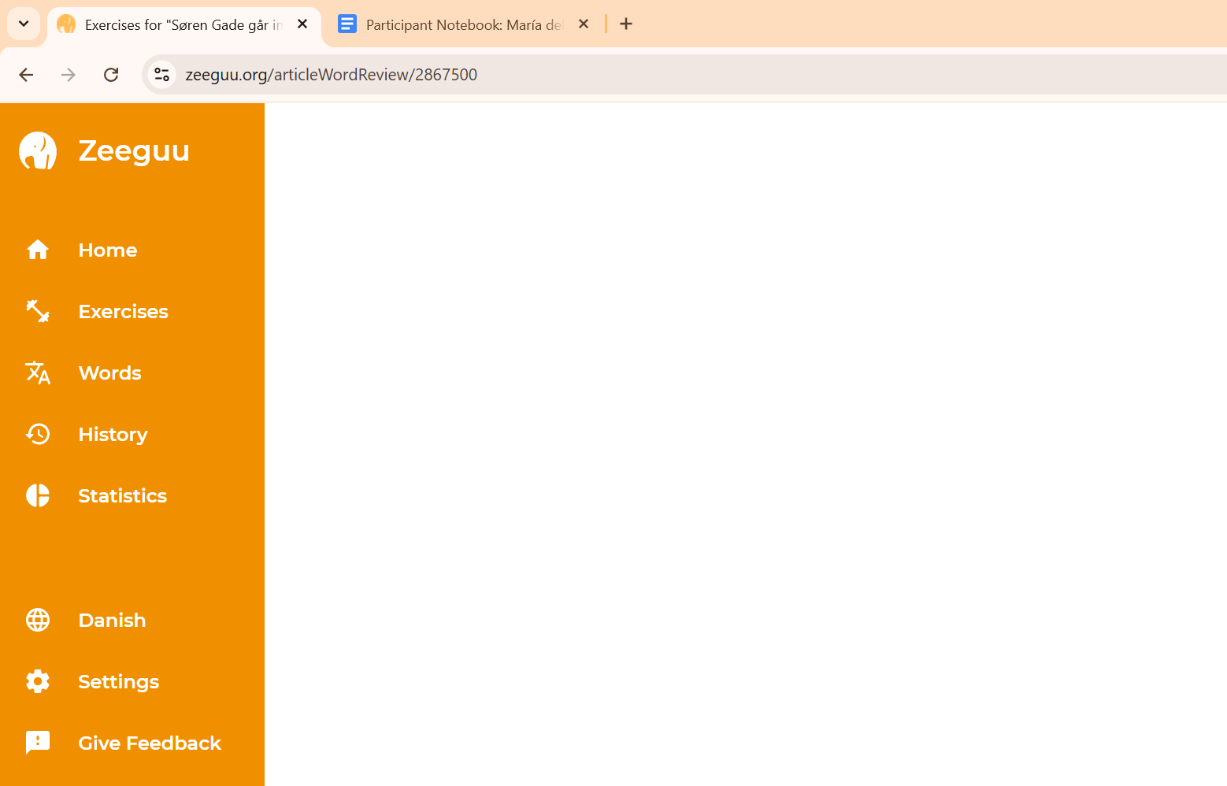
* After finishing the exercises from the current article, the site went blank

# Session 3 - Video

## Date

* 28/04/2025

## Goal

* ~~1. Watch a video on Zeeguu that you find interesting and challenging~~
* ~~2. Translate the words in the captions that you don’t understand or find difficult. If you don’t need to translate any words, the video is not challenging enough.~~

## Your Notes

* The video didn’t look good on 100% zoom in th Chrome browser. I had to zoom out in order to see the “Fullscreen” button  
  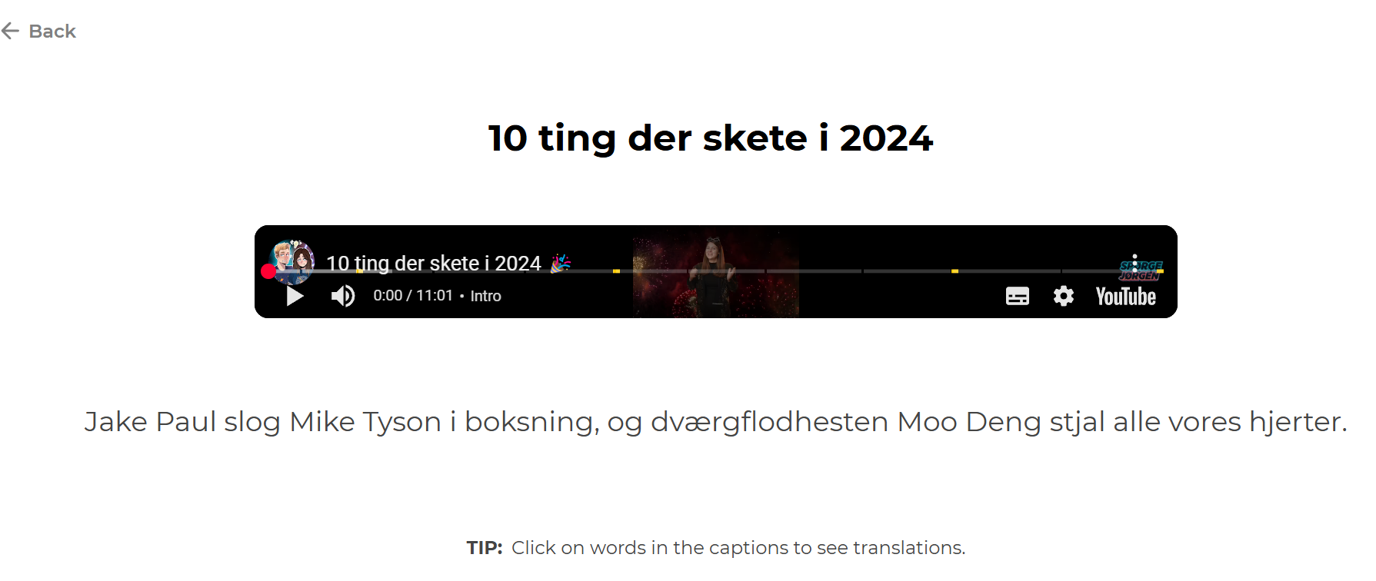
* At approx 4:30 minute the subtitles disappeared, and came back after 20 sec
* It was nice to have subtitles and the chance to translate words while watching
* It is also useful to have the speed tool from YouTube, so at some points if it feels too fast, one can slow down and understand better
* If there’s a “Save video” option, I couldn’t find it

# Session 4 - Video + Exercise

## Date

* 03/05/2025

## Goal

* ~~1. Watch a video on Zeeguu that you find interesting and challenging~~
* ~~2. Translate the words in the captions that you don’t understand or find difficult. If you don’t need to translate any words, the video is not challenging enough.~~
* ~~3. Spend 5 minutes doing exercises~~

## Your Notes

* There are some videos (cooking, sewing) that don't have speaking words and have hardcoded English subs
* It was hard again to find an appealing video - perhaps they lack relevance compared to the articles?
* After doing more exercises, the phrases where the words are used become familiar. It would be nice to be challenged with new phrases, different from the ones in the articles or videos.
* It would be nice to have an option for listening to whole sentences in the exercises, and maybe be asked to repeat out loud - even if the system can’t assess pronunciation, it helps to be encouraged to speak as well.